SmartPlant 3D Isometrics
Isometric Drawings Extraction User Training

FURTHER EDITS HAVE BEEN DONE DIRECTLY IN THE HTML DOCUMENT.
RIGHT CLICK THE htm VERSION OF THIS DOCUMENT AND SELECT EDIT TO MODIFY THE ACTUAL TRAINING DOC. THEN COPY THE FINAL DRAFT TO THE SP3D-SELF-TRAINER FOLDER.
Table of Contents

LAB-1: Out of the Box Iso Extraction 1
LAB-2: User Graphics and Text 3
LAB-3: Title Block 4
LAB-4: Isometrics by Piperun 6
LAB-5: Stress Isometrics 8

LAB-1: Out of the Box Iso Extraction

- Enter SmartPlant 3D and switch to Drawings and Reports task
- Right click on plant SP3DTrain, select New... to create a Folder
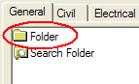
- Rename the new folder to: ISOS
- Right click on ISOS, select New... to create a Drawing By Query Manager from the General tab and OK
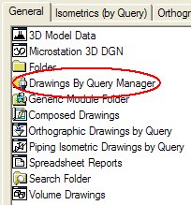
- Rename the resulting Drawing By Query Manager folder to Unit01
- Right click Unit01 and select Setup…
- Under Filter select More... and pick Training Filters>U01
- Under Packages Select More... and pick Iso Pipeline then OK
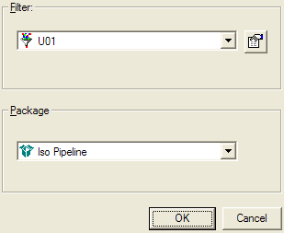
- Right click Unit01 and select Run Query
- Expand the tree structure just created under Unit01, right click Iso Pipeline and launch Create Drawings
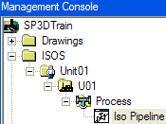
- Right click iso 1001-P and select Update Now
- Once the green check appears, right click drawing 1001-P and select Edit to review contents. Exit when done reviewing the drawing.
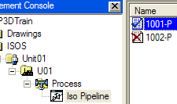
- Right click drawing 1001-P and select View Extraction Data
- Review log, pcf and isosheet drawing files
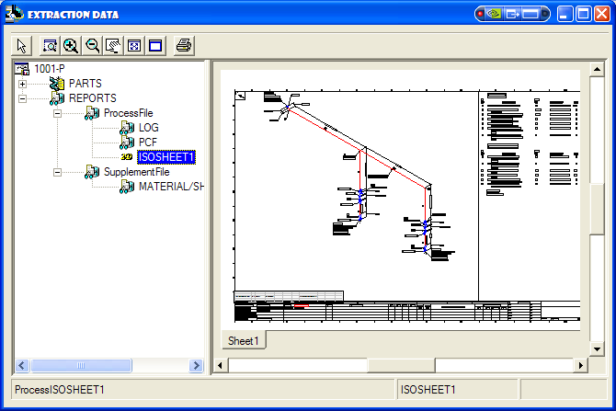

LAB-2: User Graphics and Text

- Enter SmartPlant 3D and switch to Drawings and Reports task
- Navigate to iso drawing 1001-P from Lab 1 and open in Edit mode
- Add revision clouds around the gate valves indicating a revision to the operators’ orientation.
  - Make sure to match the drawing area’s active font
  - Make sure to place manual items in “Default” or “User…” layer
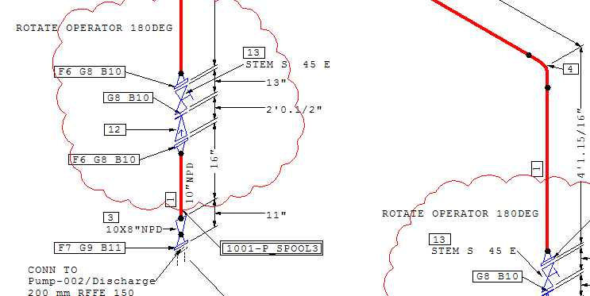
- Save and exit the drawing
- Run Update now… on this drawing
- Return to drawing 1001-P in edit mode and verify that manual graphics were preserved after iso update.

LAB-3: Title Block

- Return to drawing 1001-P’s parent folder Unit01, right click on it and select Properties
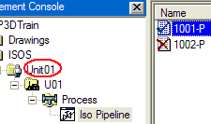
- In the Title Area tab, select the value field for Company Name and enter “SHAW GROUP”
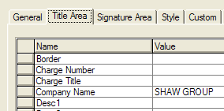
- Scroll to the bottom of the Title Area form and set the value of Title 1 to UNIT01 ISOMETRICS
- Select the Signature Area tab
- Set the initials and dates for Drawn/Designed/Checked/Approved-by fields
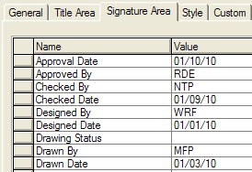
- Select OK to accept new values
- Multi-select drawings 1001-P and 1002-P, right click and select Update now
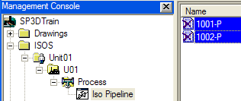
- Review the contents of the title blocks for both isos, they should resemble the following illustrations:
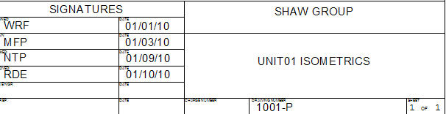
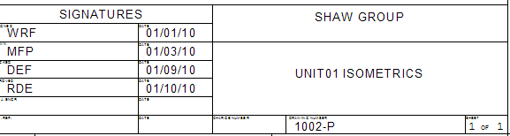
Note: In practice, the title block layout may look different per project requirements.
- For iso 1002-P only, override the checker’s initials from your default to “XYZ”
  - Right click on drawing 1002-P and select Properties…
  - Select the Signature Area tab
  - Click on Checked By value field and enter XYZ
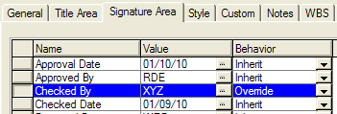
Notice the Behavior column set to Override
  - Run Update now on iso 1002-P and review the results in the title block

LAB-4: Isometrics by Piperun

- In the ISOS folder, create a new Drawing by Query Manager component and rename it “Unit02-Piperun”
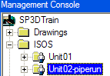
- Right click Unit02-Piperun and select Setup…
- In the select package dialog, select the Iso Piperun package (if not found, CAE will provide it)
- In the Filter dialog select more…
- Expand the Training Filters folder, select the filter U02 and OK
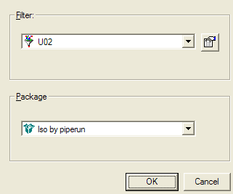
- OK to accept the Setup form
- Right click Unit02-Piperun and select Run Query. A folder tree is created
- Navigate down to the Process folder just created, right click it and select Create Drawings
- Expand pipeline folder 2002-P, select the isos by piperun component with a right click and select Update Now
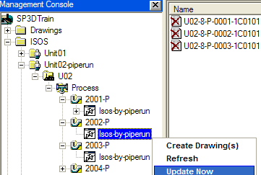
- Review the contents of the updated drawings. Notice there’s only one piperun per drawing. This method of extraction can be useful for users to check their design against Isogen, as well as diagnosing problems where system or pipeline isos are prevented from extracting successfully due to a problem in one undetermined piperun.

LAB-5: Stress Isometrics

- In the ISOS folder, create a new Drawing by Query Manager component and rename it “Unit02-Stress”
- Right click Unit02-Stress and select Setup…
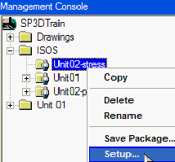
- Set the Filter to unit U02 and the Package to Iso Stress
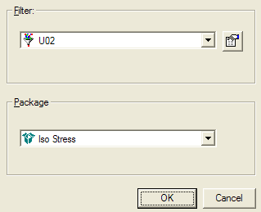
- Right click Unit02-Stress and select Run Query. A folder tree is created
- Navigate the new folders to the Iso Stress component. Right click it and select Create Drawings
- Notice that the Pipeline name drives the stress isos naming
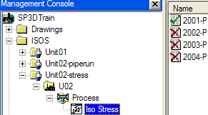
- Right click iso 2001-P and select Update Now
- Since stress isos don’t create a graphic file, right click the updated iso and select View Extraction Data…
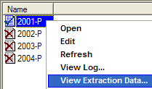
- In the Extraction Data form select PCF to view the stress analysis input data
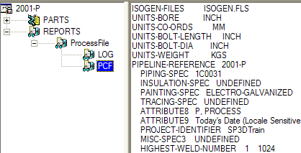
- To export the stress analysis input file (PCF), right click on iso 2001-P and select Save as…
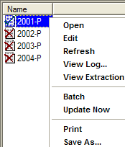
- Enter an output folder, i.e., C:\LABS, where the report should be exported to
- For Isometric Drawings under Component Type, click the Target File Type pull down, select “PCF file” and OK
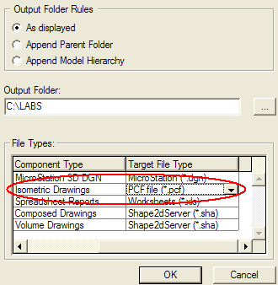
- In the Windows Explorer navigate to C:\LABS and review the file 2001-P.pcf
This file would be the input into CAESAR II for piping stress analysis.

